SUST 221 Background & Instructions for Summer Climate Change Regionalization

Concepts: exploratory data analysis, systems complexity

Students – please note that questions to be answered are in bold print. Other bold print items are things that you should learn as concepts or important details, some of which will show up in the small mid term that we will have in several weeks.

The four videos are designed to walk you through the project, and some even contain full or partial answers to a few of the questions that are in bold print in this document.

Some context is important in understanding the subject area of this project. We begin with a brief look at global climate change statistics and science.

First, we look at a graph of annual global average temperature change and the [gridded global map of temperature change](https://www.climate.gov/news-features/understanding-climate/climate-change-global-temperature) from the National Oceanic and Atmospheric Administration. (NOAA)

**What does this map show about the United States temperatures in general?**

Next view the composite graph of the anthropogenic greenhouse gas concentration, and their proportional contribution to warming. **While you probably know that carbon dioxide is the most significant one, which one is in second place?**

Next, we view some parts of the most recent Intergovernmental Panel on Climate Change 2023 AR6 draft [longer version](https://www.ipcc.ch/report/ar6/syr/) report. Two themes are:

-human causation of climate change (page 7) Note that temperatures rose up through about the end of WWII, but then there was the well-known hiatus shown in graph c) that extended through the early 1980s. This scientific consensus about the cause of this hiatus is seen in graph d) though not explicitly described. It is the gray bar that shows a negative value responsible for about -0.4 degrees C of cooling. In the title that bar is name “aerosol ___________.” This is largely from sulfur dioxide emissions. (**fill in blank above**) More on this when we get to Louisiana climate change.

Keep in mind that graph b) repeats what we saw earlier, that the key greenhouse gasses were being emitted more and more through the years, including during the warming hiatus. So, to emphasize, the hiatus does not appear to be related to greenhouse gas emissions declines, because they in fact kept rising.

-regional impacts of climate change associated with different amounts of warming. (page 35) This panel of scenarios examines outcomes related to 1.5, 2, 3, and 4 degrees C of warming. **From an annotation at the top of the panel, we are already at _____ degrees C of warming. Fill in the blank.**

For graph panel a), how much warming do we see on the hottest day of the coastal parts of the Gulf of Mexico states, relative to more interior parts of the United States? **Less or more? (circle one)** This will be germane later in the lab.

Next we view Oregon and then California Summer Climate, focusing on temperature and precipitation. We examine July and August, when summer is at its fullest development. Source data website: <https://www.ncdc.noaa.gov/cag/national/time-series>

We use the 1900 to 2000 data for context, and then examine changes in the past 22 years. Specifically, we look at decadal change 2001-2022 as may be shown in a companion video. Please note that in the video I incorrectly stated that the Oregon and California data need to be entered in the data sheet. Just summarize below.

**What are the trends in July and August temperature and precipitation overall for Oregon, 2001-2022?**

**What are the trends in July and August temperature and precipitation overall for California, 2001-2022?**

One of the common themes in the IPCC reports, one of which we just looked at, is that both severe drought and flooding are possible in some areas at different times. For Oregon and California, for the most part the big theme is summer and early fall drought caused by summer warmer temperatures and sometimes less rainfall. Flood risk is another topic for another project, perhaps. But in most places on Earth, unlike in Oregon and California, summers have more precipitation than the winter, and climate change may make some of them even rainier through time.

Accordingly, next we navigate in the NOAA site to state data for Louisiana. It represents a sort of opposite climate regime for a subtropical place, a contrast to the winter wet, summer dry climate of California – one that is prone to extreme droughts in the recent decades. While both states border on open saltwater bodies, the Gulf of Mexico has very, very warm surface water in the summer, well above 80 degrees F, while California borders on a relatively cold Pacific ocean with temperatures in the low 60s and even in the 50s. The Gulf of Mexico surface water has been warming at about [double the global rate](https://journals.ametsoc.org/view/journals/clim/36/8/JCLI-D-22-0409.1.xml) of ocean warming in the last half century. (see & enlarge Figure 3 in the report) Warmer surface water imparts more moisture to the air above it, moisture that powers stronger hurricanes and also leads to more summertime convective rainfall over land.

The **Gulf moisture gives Louisiana a water vapor content double that of California at times in the summer.** And the circulation off the Gulf extends into much of the Mississippi River basin, and even up into the Prairies of Canada in the summer. So this large region sometimes has heavy convective precipitation including thunderstorms and even tornadoes, and any additional heating just makes for more surface lifting – generally causing more rainfall. And in recent decades the moisture content of the air that is pushed into the region from a high pressure cell centered somewhere of the east coast of Florida is higher than ever in recorded history. So that makes the air more humid now in the summer than it was even a few decades ago. All of this makes for, you guessed it, more summer precipitation in the coastal areas of the Gulf and even well into the interior. This is a typical weather map for summer that shows onshore circulation from the Gulf and rainy weather. Note especially the 24 hour precipitation map at the lower right of the various panels: <https://www.wpc.ncep.noaa.gov/dailywxmap/index_20220820.html>

**Would you describe the geographic precipitation pattern to be fairly even or more irregular?**

**View the 500mb panel, lower left. The high pressure cell offshore guides air onshore from the Gulf of Mexico into the US South and farther north.**

This type of pattern is typical of convective precipitation - with plenty of surface heating and high water vapor content.

Now let’s have a look at what the EPA wrote about climate change in Louisiana. Google <what climate change means for louisiana epa> if the link below doesn’t work:

[What Climate Change Means for Louisiana (wou.edu)](https://people.wou.edu/~mcgladm/SUST%20221%20Data%20Analysis/climate-change-sulfur%20&%20circulation%20louisiana.pdf)

**What does the EPA say about the existence of warming in Louisiana in the past century?**

**What are the causes (two) for this? Yes, one is pretty vague, (“natural cycles”) the other is clearer, starts with an s. What is it?**

**The primary sources of the above cause you have identified starting with an s are coal-fired electricity plant combustion, and petroleum refining**.

The following article describes some modeling about what will happen as one of those causes is cleared up:

<https://www.nature.com/articles/s41598-020-78805-1/figures/1>

The amount of extra heating from solar radiation that eventually will be experienced in the map on the right (for the area immediately adjoining the Gulf of Mexico0 is expressed in watts per square meter. **For the coastal area of Louisiana, approximately how many watts per square meter is it?**

By the way, that is about the same number of watts that a cell phone draws when in use. Now see the graph at the top of the page of [this link](https://www.epa.gov/climate-indicators/climate-change-indicators-climate-forcing). Look at the watts scale on the right. This shows the amount of additional watts of forcing that the additional amount of greenhouse gasses cause, over time.­

**How does this graph, showing the realities just a few years ago - compare with the numbers indicated by the colors that are shown covering the SE United States from the Nature article above? (circle one)**

1. **much more**
2. **much less**
3. **about the same**

What this means is that more heating is anticipated as this one - of the two causes, is eventually solved. Also view the other graph, Figure 2. Aerosols, depending on type, have caused either warming or cooling.

**Which aerosol type has caused warming?**

**Which aerosol type has caused cooling?**

**Which of the two is larger in total effect? (in other words, if it were possible to completely get rid of both, would the net effect be warming or cooling?**

But the other cause of Louisiana not following the global trend of temperature increase is what we now turn to. So now we view the State of Louisiana climate data from the NOAA site.

We will focus on the metrics of rainfall and maximum temperature (rather than average or minimum temperature). I explain why in the video.

**Replay video (if need be) and summarize why we are focusing on trends of**

**a) rainfall and,**

**b) maximum temperature:**

**What trends do we find for July and August for the two indicators above? Enter data in sheet below.**

**What is the hypothesized relationship of one with the other? In other words, assuming a) affects b), what is the direction of causation for increased rainfall on high temperature, (up or down) and why?**

Now check the trend in Louisiana minimum temperature for both July and August for the 2001 to 2022 period, selecting the decadal trend again. (you don’t need to enter this data point. **What trend do you see? How does this statistic square with the rationale discussed in the video?**

Ok, so now we see a pattern. Is this just a Louisiana thing, or is it more widespread? To answer, we need to look at nearby states to see if this is going on there too.

Do the same investigation for other states that have territory on the Gulf: Mississippi, Alabama, Georgia, Florida, and the Texas coast.1 Fill in values in the table below. If all of them have the same pattern of more precipitation and lower maximum temperatures, then continue on with the adjoining states to the north, as listed below.

|  |  |  |  |  |
| --- | --- | --- | --- | --- |
| Decadal Trends in Precipitation and Temperature, Years 2001 - 2022 | | | | |
|  | | | | |
|  | July | | August | |
|  | Precipitation | Max Temperature | Precipitation | Max Temperature |
| Louisiana |  |  |  |  |
| Mississippi |  |  |  |  |
| Alabama |  |  |  |  |
| Georgia* |  |  |  |  |
| Florida |  |  |  |  |
| Texas Div 4 |  |  |  |  |
| Texas Div 8 |  |  |  |  |
| Arkansas |  |  |  |  |
| Tennessee |  |  |  |  |

*it is acknowledged that Georgia does not quite front on the Gulf of Mexico.

1. For Texas use Divisions 4 and 8 only, because the rest of the state is heavily influenced by air from coming from the west interior at times and as such is unlikely to have the humidity needed to drive what we see happening in Louisiana. Instructor checked the other Texas regions. Use the Division selection of Texas on the NOAA site for data access.

Now we are ready to analyze what we have found. I didn’t have you investigate this, but even states farther north of the ones we looked at show the same monthly decadal trends for precipitation and maximum temperature – for August but not quite for July. These states include West Virginia, Oklahoma, and North Dakota, and perhaps others.

**Write a one sentence summary of what was found as summarized in the data table – identifying to what extent we have found a regional pattern, which states conform to it and which ones do not.**

But just because we have a pattern in the data does not in itself prove with certainty that the changes we have seen in precipitation are the driver for the changes in high temperatures. But we started with an hypothesis, as described in the video, and our data support that hypothesis. And we have a *causal mechanism*, also in the video. **What specifically is that hypothesis, having to do with precipitation increases driving changes in maximum temperature?**

**Fill in the blank: increases in precipitation cause daytime maximum temperatures to __________.**

Now about the previously cited EPA document on climate change in Louisiana that identifies how a decrease in sulfur dioxide emissions (and therefore its atmospheric concentrations) should allow more solar radiation to reach the surface, warming the climate. Here is a graph showing the SE US region that for the most part is what we identified as geographically fitting into our overall rainfall-and-temperature regionalization:

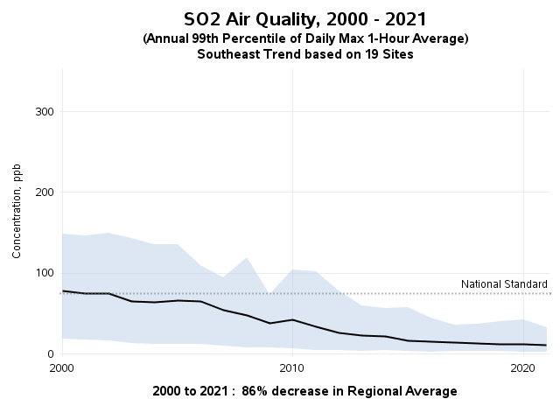

The trend is clear, and it is a huge reduction, of 85 percent. There is little doubt that a dramatic reduction in sulfur dioxide has happened during the exact period that we looked at to identify our “region”. This was supposed to allow significant warming, according to the Louisiana EPA climate change document and the Nature article. Now there is one thing we should do, and that is to look at, at least for a little check, what the change was in decadal average temperature (not high temperature) for Louisiana from 2000 to 2022. For your convenience, here are the numbers:

July: +0.3°F

August: -0.1°F

So a little warming overall in July, but not August. And from what you investigated and summarized about Louisiana’s minimum temperature trend a couple of pages back, what little warming that has happened as shown by the average temperature has been at night.

**But the effect of reducing sulfur dioxide was to warm up what period in the 24 hour cycle, day or night? (in other words, what was the reduction in sulfur dioxide supposed to have “let in”, and when would that happen, day or night?)**

So then, this weakens the argument that the sulfur dioxide reduction has caused warming, doesn’t it? But is it possible that at least some of the daytime cooling that we have hypothesized was driven by more rainfall (and presumably more cloud cover) - could have counteracted the warming forced by less sulfur dioxide? (negative feedback loop) I will discuss this in class after you turn in this assignment.

If we want to test **the hypothesis that more rainfall cools off the daytime highs, by having more rainclouds blocking incoming solar radiation…and by tying up what insolation is received by the ground in the energy intensive process of evaporating water from the surface, we are off to a good start. And more rainfall means more clouds and probably more water vapor, both of which minimize nighttime radiative heat loss and thus elevate low temperatures at night, which we see in the data.** And we also have more tools to apply to that task.

I will leave you with a red herring, just for kicks. No, we will not find this map to be useful, but given what we have been working on, you might find it interesting:

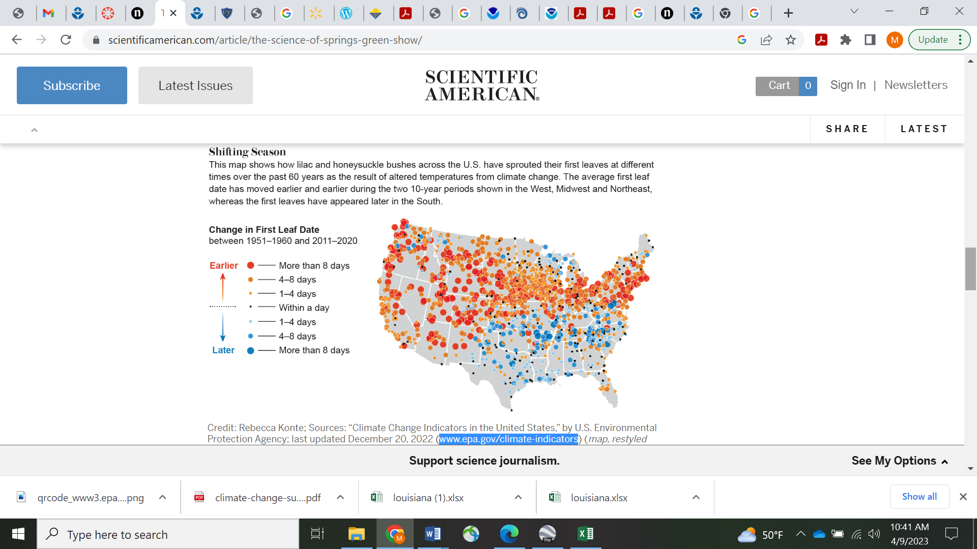

cheers